
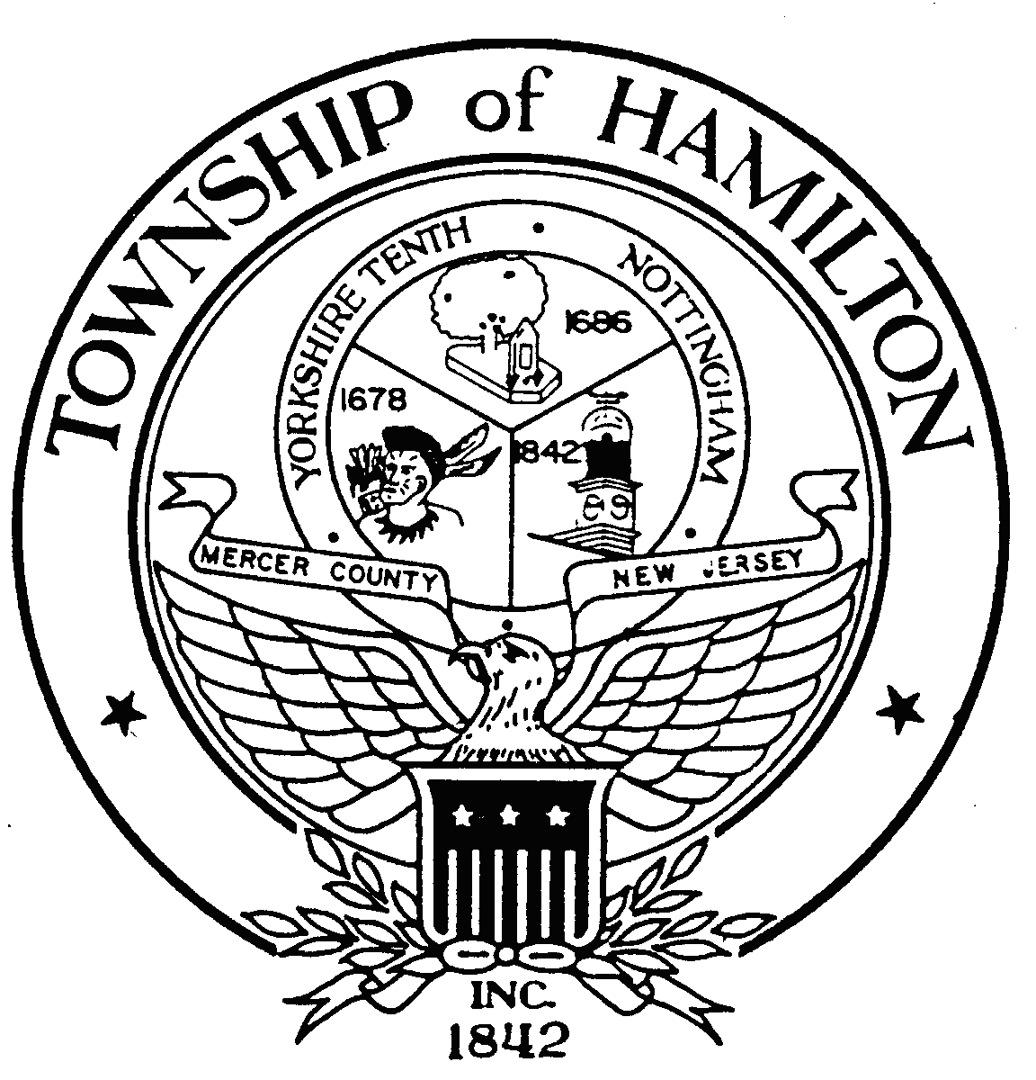

GLEN D. GILMORE
Mayor
April 3, 2007

The Honorable Frank Lautenberg The Honorable Robert Menendez
United States Senator United States Senator
324 Hart Senate Office Building 317 Senate Hart Office Building
Washington, DC 20510 Washington, D.C. 20510

Dear Honorable Gentlemen:

On March 24th of this year, I had the privilege of visiting the small mountain village of Monteleone di Spoleto, which is located about two hours north of Rome. I stopped in Monteleone for a very brief side visit during a five-day stay in Norcia, as part of a small delegation visiting Umbria in an effort to foster friendship and exchanges between our two areas of the world. My community of about 90,000 has a large Italian-American population, many with roots from this area of Italy. I had been extended an offer to visit Umbria from the Mayor of Norcia.

During my visit to Monteleone, I met with a group of about twenty-five young students from the village, along with the Mayor of Monteleone, the Honorable Nando Durastanti, in a very small community center. I told them of our hopes of promoting student exchanges, then I asked if they had any questions of me. They bashfully smiled, but asked no questions. Breaking the brief silence, the Mayor of Monteleone offered that he had a question. He asked, through an interpreter, if I would help Monteleone get back the Chariot of Monteleone. When I responded with a puzzled look, not having heard of the chariot before, the translator quickly explained that the village had been trying to have a very special chariot returned to them after it had been smuggled out of their village and country a little over a hundred years ago, finding its way to the Metropolitan Museum of Art. Accepting their version of events at face value, I promised the Mayor of Monteleone that I would help him try to get the chariot returned to his village, trusting that they would welcome visitors to Monteleone to see the chariot once it was returned to their village. As my response was translated into Italian, the children broke into spontaneous applause and beaming smiles.

Having researched further the circumstances of the chariot’s removal from Monteleone – and believing that the removal of the chariot from Monteleone and Italy was in violation of Italian law existing at that time, and a violation of just plain decency, I have written to the Director of the Metropolitan Museum of Art asking that the chariot of Monteleone be returned to the village of Monteleone. This seems only fair and just to me.

I have also received a copy of a letter sent by the Metropolitan on December 17th of 2004, to a lawyer, Tito Mazzetta, a Monteleone native now living in Atlanta, Georgia, who has been representing the village in its claim to have the chariot returned. In that letter, I was greatly disappointed to hear the Met say of the village’s claim to have the chariot returned that this claim “came as
Mayor Glen D. Gilmore
Chariot of Monteleone di Spoleto

April 3, 2007
Page 2

something of a surprise, as the Metropolitan has owed the Chariot for over one hundred years, long after any legal claim could be timely brought.” I have always been a great fan of the Met and its profound commitment to preserving and displaying the great natural, historic, and artistic treasures of the world. I would never have imagined the Met to respond to a claim for the restoration of a smuggled artifact by citing a statute of limitations.

Since the Met is a regular beneficiary of federal grants, I am writing to ask for your support in having the Chariot of Monteleone returned to the village of Monteleone. It is critical that those institutions receiving taxpayer dollars be held to the highest standards of ethical conduct. Citing the expiration of a statute of limitations as a defense for refusing to return to a village a prized artifact that was smuggled out of the borders of one of America’s greatest allies is hardly the sort of conduct that one would expect from one of the world’s greatest institutions of Art, especially one receiving substantial taxpayer dollars. Institutions receiving taxpayer dollars must be held to the highest standards of ethical conduct.

My hope is that the Metropolitan will still decide for itself that the Chariot of Monteleone should be returned to the village of Monteleone, since its current position could almost be cited as an invitation for the smuggling and hiding of great works of art, waiting for a statute of limitations clock to expire. We should demand higher standards than this.

In addition to asking that the Chariot of Monteleone be returned to the village of Monteleone, I am also requesting that the Metropolitan, which has been benefited for over a hundred years from the possession of this spectacular Etruscan Chariot, provide both technical and financial assistance to allow the Chariot to be safely transported back to Italy and properly displayed upon its return. Again, this strikes me as a reasonable request given the fact that the Met has benefited for so many years from the possession of this treasured work of Art and History.

Having met with the Mayor of Monteleone, some village leaders, and, most importantly, with the children of Monteleone, there is no doubt in my mind that the Chariot of Monteleone should be returned to people of Monteleone. For this small village, which depends almost exclusively on tourism and farming, the return of the Chariot of Monteleone would ensure a brighter future for their entire community, while also reaffirming the Metropolitan’s rightful place as a world-class – and world-respected -- protector of artifacts. Your assistance in helping this to happen would be much appreciated. Thank you.

Sincerely and respectfully,


Glen D. Gilmore
Cc: The Honorable Mayor of Monteleone di Spoleto, Nando Durastanti

