
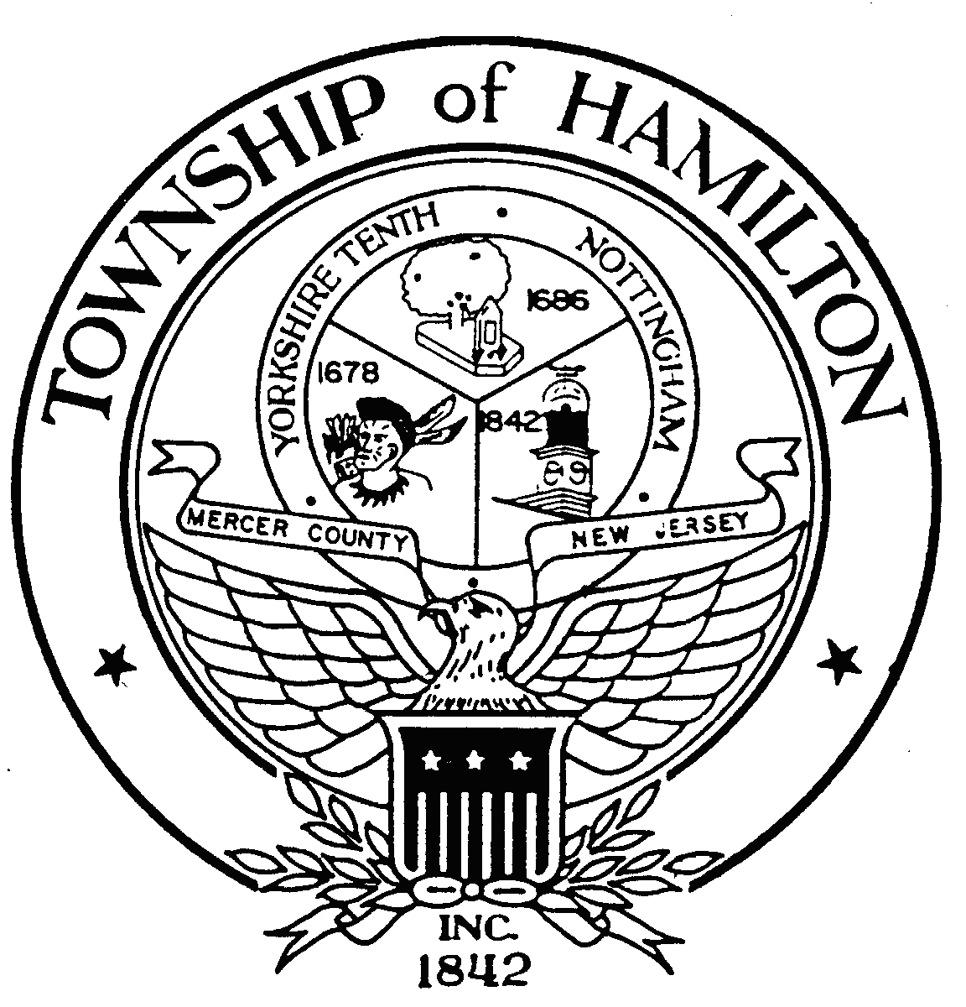

GLEN D. GILMORE
Mayor

April 2, 2007

Director Philippe de Montebello
The Metropolitan Museum of Art
1000 Fifth Avenue
New York, New York 10028-0198

Dear Director Philippe de Montebello:

On March 24th of this year, I had the privilege of visiting the small mountain village of Monteleone di Spoleto, which is located about two hours north of Rome. I stopped in Monteleone for a very brief side visit during a five-day stay in Norcia, as part of a small delegation visiting Umbria in an effort to foster friendship and exchanges between our two areas of the world. My community of about 90,000 has a large Italian-American population, many with roots from this area of Italy. I had been extended an offer to visit Umbria from the Mayor of Norcia.

During my visit to Monteleone, I met with a group of about twenty-five young students from the village, along with the Mayor of Monteleone, the Honorable Nando Durastanti, in a very small community center. I told them of our hopes of promoting student exchanges, then I asked if they had any questions of me. They bashfully smiled, but asked no questions. Breaking the brief silence, the Mayor of Monteleone offered that he had a question. He asked, through an interpreter, if I would help Monteleone get back the Chariot of Monteleone. When I responded with a puzzled look, not having heard of the chariot before, the translator quickly explained that the village had been trying to have a very special chariot returned to them after it had been smuggled out of their village and country a little over a hundred years ago, finding its way to the Metropolitan Museum of Art. Accepting their version of events at face value, I promised the Mayor of Monteleone that I would help him try to get the chariot returned to his village, trusting that they would welcome visitors to Monteleone to see the chariot once it was returned to their village. As my response was translated into Italian, the children broke into spontaneous applause and beaming smiles.

Having researched further the circumstances of the chariot’s removal from Monteleone – and believing that the removal of the chariot from Monteleone and Italy was in violation of Italian law existing at that time, and a violation of just plain decency, I am writing to request that the chariot of Monteleone di Spoleto be returned to the village of Monteleone di Spoleto. This seems only fair and just to me.

I have received a copy of a letter sent by the Metropolitan on December 17th of 2004, to a lawyer, Tito Mazetta, a Monteleone native now living in Atlanta, Georgia, who has been representing the village in its claim to have the chariot
Mayor Glen D. Gilmore
Chariot of Monteleone di Spoleto

April 2, 2007
Page 2

returned. In that letter, I am greatly disappointed to hear the Met say of the village’s claim to have the chariot returned that this claim “came as something of a surprise, as the Metropolitan has owed the Chariot for over one hundred years, long after any legal claim could be timely brought.” I have always been a great fan of the Met and its profound commitment to preserving and displaying the great natural, historic, and artistic treasures of the world. I would never have imagined the Met to respond to a claim for the restoration of a smuggled artifact by citing a statute of limitations.

The great Democracy of Italy is a place where many of our world’s greatest treasures are preserved, cherished and displayed. Having met with the Mayor of Monteleone, some village leaders, and, most importantly, with the children of Monteleone, there is no doubt in my mind that the Chariot of Monteleone should be returned to people of Monteleone.

I am hopeful that the Met, after having had the benefit of this great artifact for over a century, would agree to its return with a commitment of technical and financial assistance that would ensure its safe transport and display. I am also confidant that the village of Monteleone would also welcome discussions on how to make sure this great artifact is seen by as many visitors as possible. For this small village, which depends almost exclusively on tourism and farming, the return of the Chariot of Monteleone would ensure a brighter future for their entire community, while reaffirming the Metropolitan’s rightful place as a world-class – and world-respected -- protector of artifacts.

Sincerely and respectfully,


Glen D. Gilmore

Cc: The Honorable Mayor of Monteleone di Spoleto, Nando Durastanti

